1. Unzip the TrainYourOwnYOLO folder into C drive.
2. Open Anaconda terminal as administrator and Create separate environment:

conda create -n yoloTraining python=3.6

1. Activate the created environment:

conda activate yoloTraining

1. Go to TrainYourOwnYOLO directory in terminal and install necessary package run the requirements.txt file:

pip install -r requirements.txt

1. Download VOTT and open the tool and start new project.
2. Enter Display name and click on Add connection in source connection and select provider as local file system and select the folder from the TrainYourOwnYOLO folder and save the connection.

Eg: C:\Users\saich\TrainYourOwnYOLO\Data\Source_Images\Training_Images

1. Select the source connection which we created and make sure source and target connection have same folder paths.

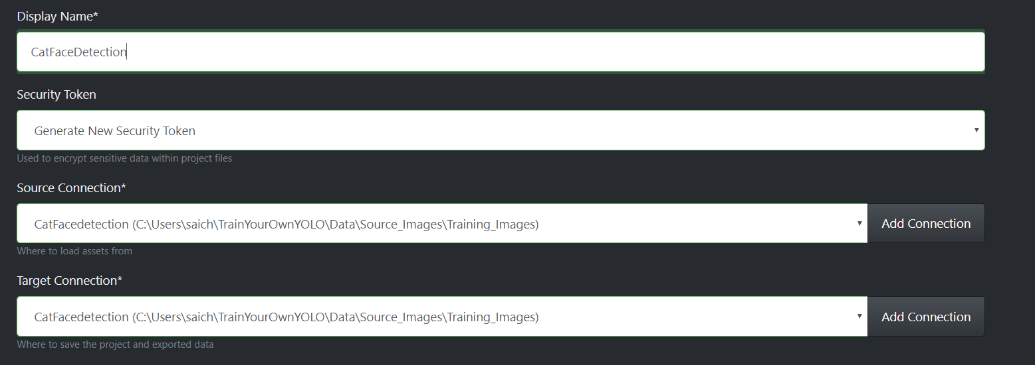

1. Click on Export icon on left side and select provider as CSV and save export settings
2. Images will appear in the tool. You need to create tag by clicking add sign and assign necessary name as below:

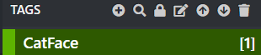

1. Click on each image and select the bounding box and click on the tag you assigned

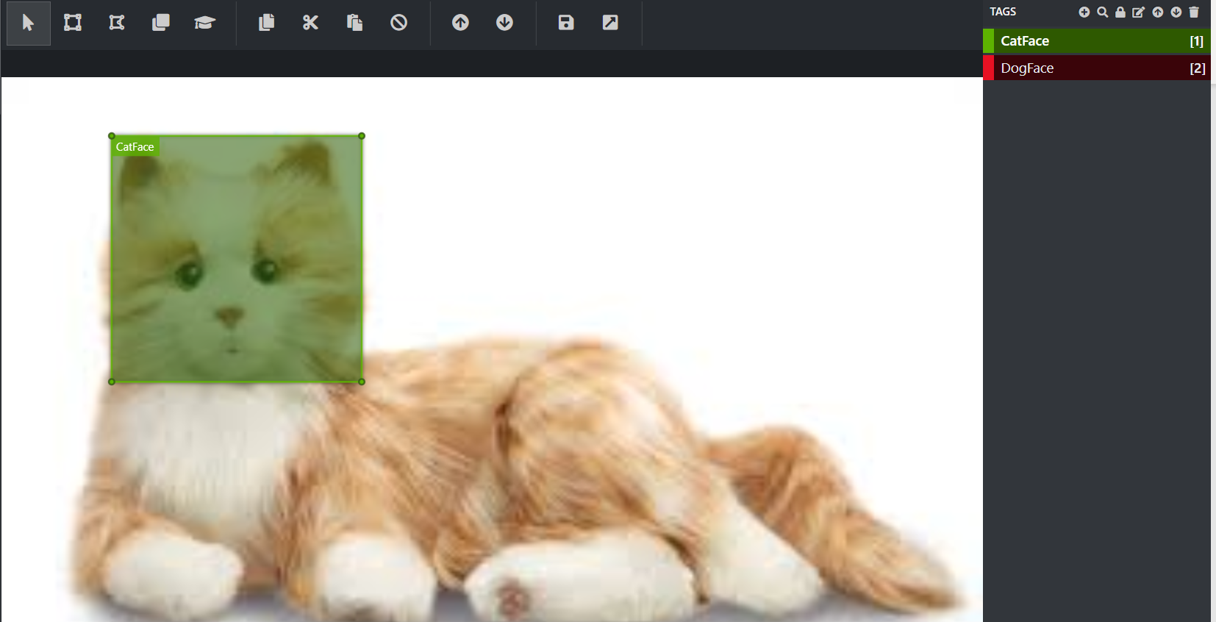

1. Do it for all the training images and export the data by clicking on ctrl+E. One folder will get created in the training images folder as vott csv export
2. open the Convert_to_YOLO_format.py externally and make sure the file name in the script and the generated csv are same. If not make sure both have same name.

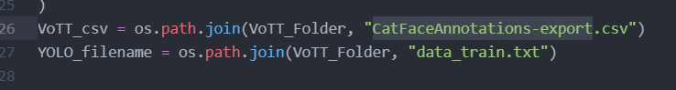

1. In terminal navigate to 1_Image_Annotation folder and run the Convert_to_YOLO_format.py script:

Cd 1_Image_Annotation/

python Convert_to_YOLO_format.py

1. Navigate to 2_Training folder and run Download_and_Convert_YOLO_weights.py script, next run Train_YOLO.py script.
2. Navigate to 3_Inference folder and run Detector.py script for testing data set.
3. Test_Image_Detection_Results gets generated in the data folder.